**Practical No.09**

**Aim: Programs based on Structure and Union**

**1. C Program to Create a Book Structure.**

**Program:**

#include<stdio.h>

#include<conio.h>

#include<string.h>

struct books

{

char title[50];

char author[50];

char subject[100];

int bookid;

};

void main()

{

struct books book1;

struct books book2;

clrscr();

// book1 specification

strcpy(book1.title," c programming");

strcpy(book1.author," Kanetkar");

strcpy(book1.subject," programming with c");

book1.bookid=1;

// book2 specification

strcpy(book2.title," Begining with python");

strcpy(book2.author," john");

strcpy(book2.subject," programming in python");

book2.bookid=2;

// print book1 information

printf("book1 title\t %s",book1.title);

printf("\nbook1 author\t %s",book1.author);

printf("\nbook1 subject\t %s",book1.subject);

printf("\nbook1 bookid\t %d",book1.bookid);

// print book2 information

printf("\nbook2 title\t %s",book2.title);

printf("\nbook2 author\t %s",book2.author);

printf("\nbook2 subject\t %s",book2.subject);

printf("\nbook2 bookid\t %d",book2.bookid);

getch();

}

**Output:**

book1 title c programming

book1 author Kanetkar

book1 subject programming with c

book1 bookid 1

book2 title Begining with python

book2 author john

book2 subject programming in python

book2 bookid 2

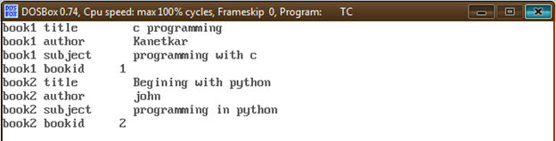

**2. C Program to create a simple Data Structure using Union**

**Program:**

#include <stdio.h>

#include <conio.h>

#include <string.h>

union Data

{

int i;

float f;

char str[20];

};

void main()

{

union Data data;

clrscr();

data.i = 10;

printf( "data.i : %d\n", data.i);

data.f = 220.5;

printf( "data.f : %f\n", data.f);

strcpy( data.str, "C Programming");

printf( "data.str : %s\n", data.str);

getch();

}

**Output:**

data.i : 10

data.f : 220.500000

data.str : C Programming

